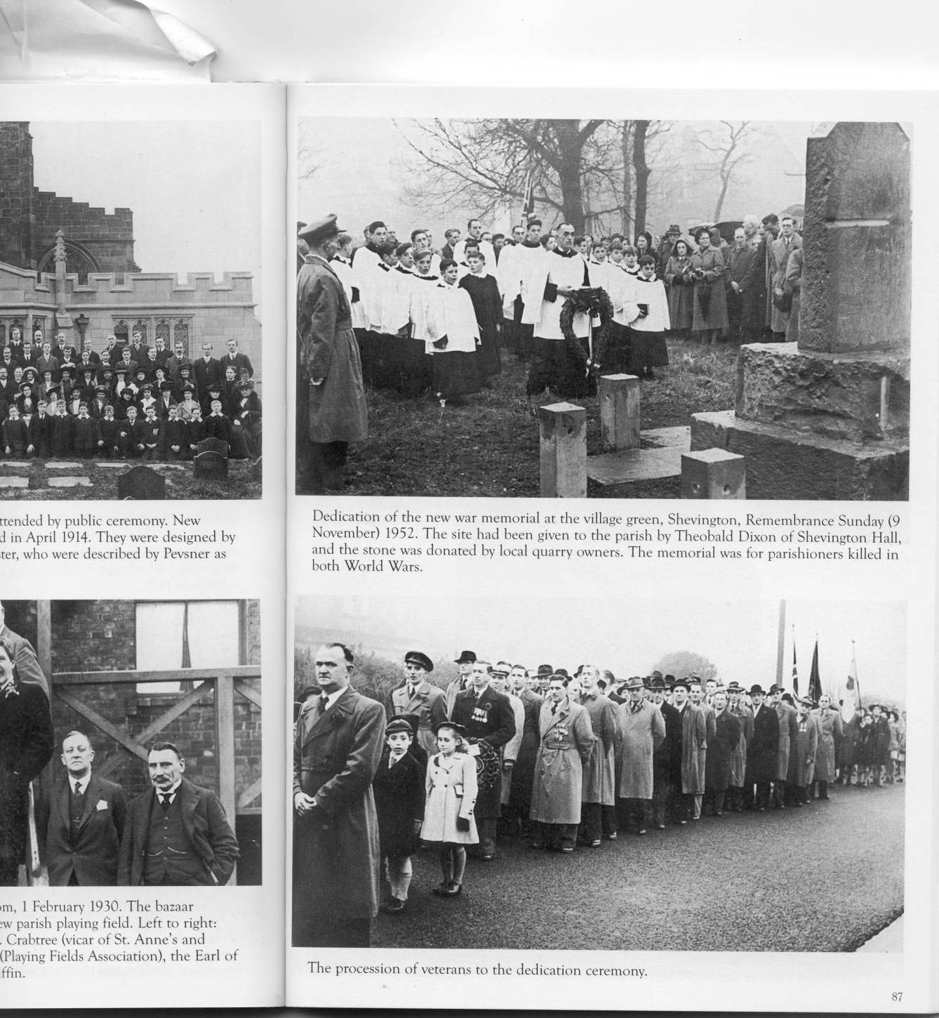

SHEVINGTON WAR MEMORIAL
DEDICATION ON VILLAGE GREEN
From the Wigan Observer, November 15th, 1952
“Remembrance Day this year will be specially remembered by the villagers of Shevington, for it marked the dedication of a war memorial and memorial garden on the village green. The memorial, which takes the form of a stone base and a centre column, is a gift from Messrs W. Finch (Appley Bridge) Ltd., quarry owners, and is in commemoration of the men of the village who laid down their lives during the two wars. A stone enclosure round the column is being given by Messrs Platt and Co., quarry owners, also of Appley Bridge. The memorial garden is being made by Shevington Parish Council on a site presented to the village six years ago by Mr TM.Dixon of Shevington Hall. Hundreds took part in the moving ceremony which was conducted by the vicar of Shevington Parish Church, Rev. H.S.Crabtree.
The chairman of Shevington Parish Council, Councillor J.Prescott and the Chairman of Wigan Rural District Council, Councillor J.K.Hodge, along with members and officials of both councils and members of the public, assembled at Shevington Broad o’th’Lane Secondary Modern School and walked in procession to the village green. Marshalled by Inspector J.Owen (Special Constabulary) the procession also comprised members of Wrightington Parish Council, Shevington Parish Church Choir, church wardens and sidesmen of Shevington Parish Church, Standish Subscription Band, Superintendent W.Boulton (St John Ambulance Brigade, Wigan Corps), the Chaplain (Rev. G. E. Stevens) and members of Appley Bridge British Legion,
Shevington and Appley Bridge ex-servicemen, Shevington and Appley Bridge troops of boy scouts and girl guides, St Wilfrid’s (Standish) Church Boys’ Brigade, representatives of Catholic and Methodist churches in the district and many schoolchildren.
Standish Subscription Band rendered music for the dedicatory ceremony which followed a service in the Parish Church. The hymns, “All people that on earth do dwell,” and “O God, our help in ages past” were sung. The vicar dedicated the memorial, “In grateful memory of the men of the village who laid down their lives in two world wars for their friends and in the cause of justice and peace.” In a tribute to the fallen, the Vicar expressed the wish that a complete record of the names of those who had died should be inscribed on the memorial.
Many wreathes, mostly of poppies, were laid on behalf of the inhabitants, school children, and various organisations. Buglers of St Wilfrid’s Church Boys’ Brigade sounded the “Last Post” and “Reveille”. Concluding prayers were said by Rev. H.S.Crabtree, and the playing of the National Anthem completed a most impressive ceremony.
The picture shows the scene on the village green at the unveiling ceremony and some of the many people who attended.

